commodities data 5-1
Commodities Data 5-3
Introduction 5-3
Consumption 5-3
Adding Consumption Data 5-4
Beginning In 5-5
For the Next 5-5
Editing Consumption Data 5-7
Deleting Consumption Data 5-7
Shipments 5-7
Adding Shipment Data 5-8
Shipment Data Tab 5-9
Order (actual/estimated) 5-10
Ship (actual/estimated) 5-10
Cost (actual/estimated) 5-11
Freight (actual/estimated) 5-11
Editing Shipment Data 5-11
Copying Shipment Data 5-12
Plan Shipments By Date 5-12
Deleting Shipment Data 5-13
Stock 5-13
Adding Stock Data 5-15
Entering Stock Count Data 5-15
Editing Stock Data 5-17
Deleting Stock Data 5-17

commodities data
Figure 5-1—Consumption screen 5-4
Figure 5-2—Consumption screen data entry area 5-4
Figure 5-3—Shipments screen 5-8
Figure 5-4—Shipments screen data entry area 5-8
Figure 5-5—Plan By Date window 5-12
Figure 5-6—Stock screen 5-14
Figure 5-7—Stock screen data entry area 5-15
Figure 5-8—Stock Count window 5-16
Figure 5-9—Stock Count window with adjustment 5-16

Commodities Data

Introduction
The Commodities Data option helps you track the movement of stock within your pipeline. Stock movements are events that change the stock quantity of a product in a program’s entire logistics system. Stock movements belong to one of the following categories:

- Consumption—stock dispensed by the program to clients

- Shipments—stock received by the program from suppliers

- Stock—amount of product on hand, expressed in two ways:

- Stock count—physical inventory of stock on hand within the entire program.

- Stock adjustments—events or transactions that change the stock on hand within the entire program (i.e., loss of expired stock, transfers to or from another program, and others).

Consumption
 | PipeLine does not track a transfer or distribution of stock within the program. These movements must be recorded in the program’s logistics management information system.
Use the Consumption Tree View option to track actual or forecast consumption quantities of products dispensed to users, or sold by the program to clients.

- Actual Consumption—reported or estimated quantities of product that left the program’s logistics system through normal dispense to clients activities.

- Forecast Consumption—quantities expected to be dispensed in the future.

- Click on the Consumption Tree View option.

PipeLine displays the Consumption screen (see Figure 5-1).

Adding Consumption Data
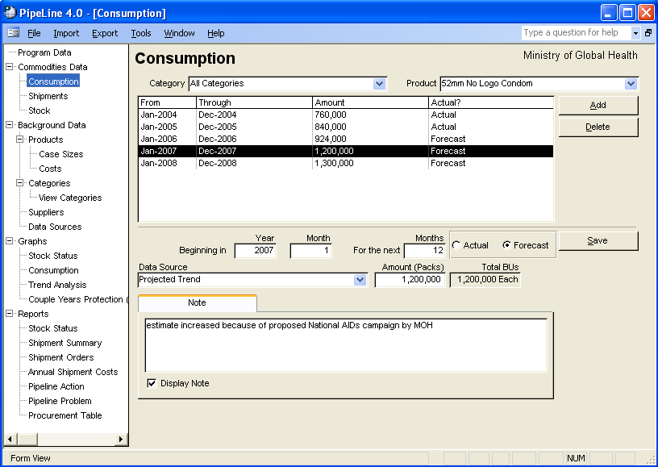
Figure 5-1—Consumption screen
To add consumption data from a file generated by an external forecasting system, see PipeLine Utilities – Import Consumption Data section. Use the Add button to add consumption data for a particular product.

With the Consumption screen displayed—

- Click on the arrow next to the Category field, and select a category from the pull-down menu.

- Click on the arrow next to the Product field, and select the product you want to add consumption data to.

- Click on the Add button.

PipeLine blanks out the lower half of the Consumption screen (see Figure 5-2).
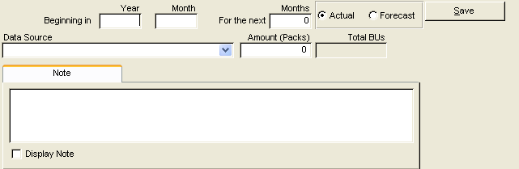
Figure 5-2—Consumption screen data entry area

Beginning In
This area enables you to set the consumption period, which can be any number of months.

The Year field shows the calendar year when the consumption period begins.

- Type the four-digit year.

The Month field shows the month that marks the start of the consumption period. For example, “1” shows that the first month of the year is the start of the consumption period.

- Click in the Month field, and type the month when the consumption period begins.

For the Next
The For the Next Months field shows the number of consecutive months in the consumption period. For example, “3” indicates a period of three months (one quarter).

- Click in the For the Next Months field, and type the length of the consumption period (in months).

The Actual field shows that the consumption data comes from an actual source (for example, physical inventory records, dispense logs, etc.).

- Click on the Actual field if the consumption data comes from an actual source.

The Forecast field shows that the consumption data is an estimated projection.

- Click on the Forecast field if the consumption data comes from a forecast estimate.

The Data Source field shows the type of data used to compute consumption.

- Click on the arrow next to the Data Source field, and select a data source from the pull-down menu.

The Amount field shows the amount of consumption for this period. To calculate consumption for reports and graphs, this amount is divided by the number in the For the Next Months field.

- Click in the Amount field, and type the consumption amount.

 | Total BUs (Basic Units) Total consumption Basic Units (BUs) are displayed. This is your consumption amount converted to basic units. (Pack times pack size.)

The Note field is a memo area used to include additional information about the data.

- Click on the Note field, and type any relevant notes about the consumption data.

The Display Note field tells PipeLine to include the note in PipeLine reports.

- Click on the Display Note field to include the note in reports.

- Click on the Save button to save the data.

Editing Consumption Data
Consumption data for a particular product can be edited.

With the Consumption screen displayed—

- Select the Category for the product you want to edit.
 | If you do not recall the name of the category for the product you need to edit, select All Categories from the Category pull-down menu to access all the products in your program.

- Click on the arrow next to the Product field, and select the product you need to edit from the pull-down menu.

- Click on the consumption data you need to edit.

- Click in the field you need to edit, and type the new data.

- Click on the Save button to save the data.

Deleting Consumption Data
Use the Delete button to the delete the consumption data for a particular product.

With the Consumption screen displayed—

- Click on the Category field, and select the category from the pull-down menu.

- Click on the arrow next to the Product field, and select the product that you need to delete consumption data from.

- Click on the consumption data you need to delete.

- Click on the Delete button, and a confirmation is displayed.

- Click on Yes to delete the selected consumption data.

Shipments
Use the Shipment Tree View option to add, modify and delete shipping data.

- Click on the Shipments Tree View option to display the Shipments screen (see Figure 5-3).

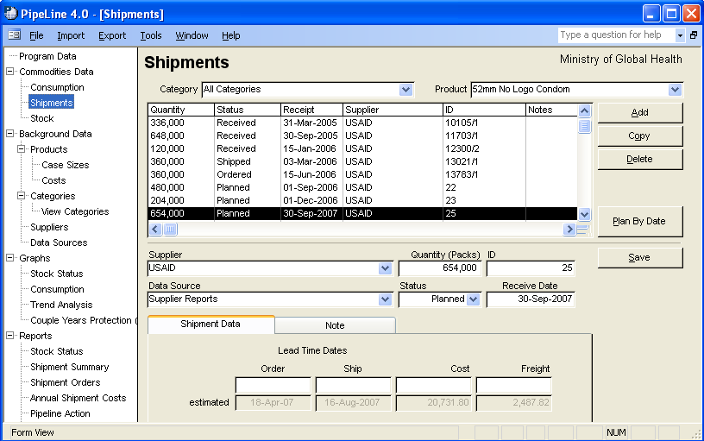

Figure 5-3—Shipments screen Adding Shipment Data
Use the Add button to add shipment data to a particular product.

With the Shipments screen displayed—

- Click on the arrow next to the Category field, and select the category from the pull-down menu.

- Click on the arrow next to the Product field, and from the pull-down menu, select the product receiving the shipment data.

- Click on the Add button.

PipeLine blanks out the lower half of the Shipment screen (see Figure 5-4). The Supplier values will drop down (not shown), and the Status field will display a default value of “Planned.”
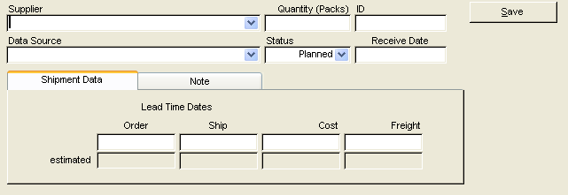
Figure 5-4—Shipments screen data entry area

- Select the shipment’s supplier from the pull-down menu.

- Click in the Quantity field, and type the shipment quantity (in units).

The ID field uniquely identifies the shipment. You can use the NEWVERN shipment number, a purchase order number, an invoice number, or any other unique identifier. You can also accept the PipeLine-generated code.

To enter a code of your choice—

- Click in the ID field, and type the shipment ID.

The Data Source field shows the data source associated with the shipment record.

- Click on the arrow next to the Data Source field, and select the data source from the pull-down menu.

The Status field shows the shipment’s status. The default value for this field is Planned. To change the default value—

- Click on the arrow next to the Status field, and select the shipment status from the pull-down menu.

The Receive Date field shows the date the shipment was or is expected to be received.
Each shipment record must have a receipt date.

- Click in the Receive Date field, and type the shipment’s receipt date.

After entering a value in the Receive Date field, depending on the quantity entered and the background product information, a message window be displayed, which notes that the quantity entered does not reflect the Product/Supplier case size. PipeLine will prompt you to round the value to the nearest Product/Supplier case size. Select “Yes” or “No.”

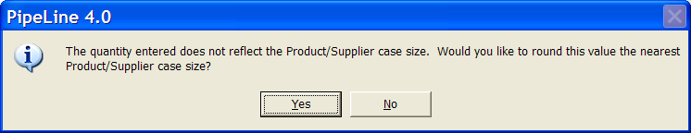

Shipment Data Tab
The Shipment Data tab displays the shipment’s actual or estimated lead times, and the shipment and freight cost.

Order (actual/estimated)
The top field shows the actual date the shipment was or is to be ordered. The Estimated field is calculated based on lead times for the supplier. To override the estimate—

- Click on the top field, and type the shipment’s order date.

Ship (actual/estimated)
The top field shows the date the shipment was or is to be shipped. The Estimated field is calculated based on lead times for the supplier. To override the estimate—

- Click on the top field, and type the ship date.

Cost (actual/estimated)
The top field shows the shipment’s actual cost. The Estimated field is calculated based on the product’s current effective product cost on the ship date. To override the estimate—

- Click on the top field, and type the shipment’s exact cost.

Freight (actual/estimated)
The top field shows the actual freight cost. This amount includes any additional charges (i.e., clearance fees) incurred while getting the product delivered. The estimated field shows a calculation based on a percentage of the product cost. To change the estimate—

- Click on the top field, and type the shipment’s actual freight cost.

The Note Tab has a memo field for additional information about the shipment.

- Click on the Note Tab, and type any relevant notes about the shipment.

The Display Note field tells PipeLine to include the note in the PipeLine reports.

- Click on the Display Note field to include the note in PipeLine reports.

- Click on the Save button to save the data.

Editing Shipment Data
Shipment data for a particular product can be edited.

With the Shipments screen displayed—

- Select the Category for the product you want to edit.
If you do not remember the category for the product you need to edit, select All Categories from the Category pull-down menu to access all the products in your program.

- Click on the arrow next to the Product field, and from the pull-down menu, select the product you need to edit.

- Click on the shipment record you need to edit.

- Click in the field you need to edit, and type the new data.

- Click on the Save button to save the data.

Copying Shipment Data
The Copy button enables you to copy shipment data. Copied data can be edited to reflect a particular shipment, which reduces the amount of data entry required.

With the Shipments screen displayed—

- Click on the arrow next to the Category field, and select the category for the product you need to copy shipment data from.

- Click on the arrow next to the Product field, and select the product you need to copy shipment data from.

- Selected the shipment data you need to copy.

- Click on the Copy button.
!! | You must enter a new receipt date in the Receive Date field.  PipeLine assigns an ID number to the copied data.
- Edit the shipment record, as needed.

- Click on the Save button to save the changes.

Plan Shipments By Date
PipeLine enables you to add shipments based on the amount of stock needed to reach a desired stock level on a date you specify for selected products. Use the Plan By Date button to plan shipments.

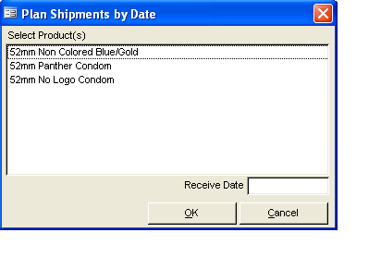
Figure 5-5—Plan By Date window With the Shipments screen displayed—

- Click on the Plan By Date button.

The Plan By Date window is displayed (see Figure 5-5). This window includes every product in the currently selected category for the current program.

- Click on the product(s) you want to plan based on the product’s receipt date.

- Click in the Receive Date field, and type the date you want the shipment(s) delivered.

- Click on the OK button.

If the receipt date you enter is not the last day of the current month, a message is displayed.
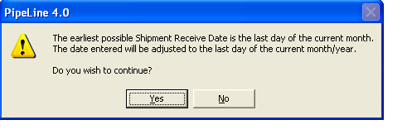

- Click on the Yes button.

Deleting Shipment Data
Use the Delete button to delete the shipment data of a particular product.

With the Shipments screen displayed—

- Click on the arrow next to the Category field, and select the category from the pull-down menu.

- Click on the arrow next to the Product field, and select the product from the pull-down menu.

- Select the shipment record you need to delete.

- Click on the Delete button, and a confirmation message is displayed.

- Click on Yes to delete the selected shipment data.

Stock
Use the Stock Tree View option to track products already in stock, or to track products during a physical inventory of your entire program when the stock balances are known or estimated.

- Click on the Stock Tree View option.

PipeLine displays the Stock screen (see Figure 5-6).
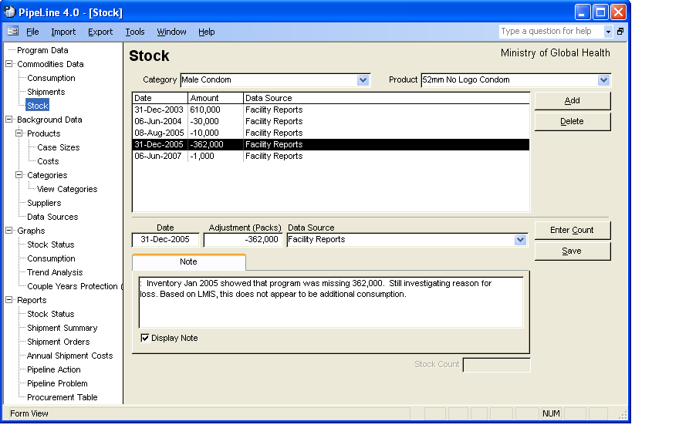
Figure 5-6—Stock screen

Adding Stock Data
Use the Add button to record positive or negative quantities that would change a program’s stock balance. These changes are not due to consumption or shipments. They are, most often, due to losses or transfers.

With the Stock screen displayed—

- Click on the arrow next to the Category field, and select the category from the pull-down menu.

- Click on the arrow next to the Product field, and select the product from the pull-down menu.

- Click on the Add button.

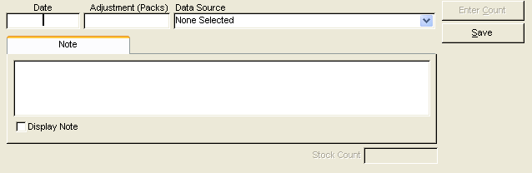
Figure 5-7—Stock screen data entry area PipeLine blanks out the lower half of the Stock screen (see Figure 5-7).

The Date field displays the date the adjustment occurred, or when it is expected to occur.

- Type the date of the adjustment.

The Adjustment (Packs) field shows the adjustment amount (in units).
- A loss is recorded as a negative number (i.e., -1, -33, -100, etc.). This adjustment is subtracted from the month’s ending balance.

- A transfer into your program from another program is recorded as a positive number (for example, 1, 33, 100, etc.). This adjustment is added to the month’s ending balance.

- Click in the Adjustment (Packs) field, and type the adjustment amount.

Entering Stock Count Data
Use the Enter Count button to calculate an adjustment based on the inventory count data.

- Click on the Enter Count button.
 | You must enter a date before you can use the Enter Stock Count feature.

The Stock Count window is displayed (see Figure 5-8).
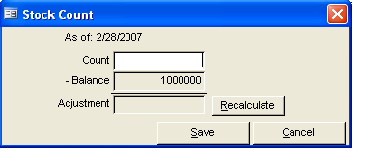
Figure 5-8—Stock Count window

The Count field displays the amount of the product in stock (in units) as of the date you specified. This value includes storage facilities and service delivery points.

- Type the stock count.

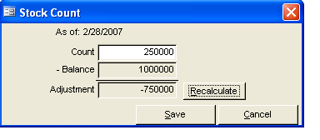
Figure 5-9—Stock Count window with adjustment The Recalculate button allows PipeLine to calculate the adjustment by subtracting the current balance from the entry in the count field. Figure 5-9 displays the Stock Count window, and shows an adjustment based on supplied data.

- Click on the Save button to save
the data.

PipeLine populates the Adjustment and Stock Count fields based on the data you enter.

The Data Source field displays the source of the adjustment.

- Click on the arrow next to the Data Source field, and select the data source from the pull-down menu.

The Note field is a memo field where you can enter additional information about the adjustment.
- Click on the Display Note field to include the note in the PipeLine reports.
!! | Always explain the adjustment.  - If a loss, note the reason for the loss.  - If a transfer, note the source or destination of the transfer.

- Click on the Save button to save the data.

Editing Stock Data
Stock data for a particular product can be edited.

With the Stock screen displayed—

- Select the Category for the product you want to edit.
If you do not remember the category for the product you need to edit, select All Categories from the Category pull-down menu to access all the products in your program.

- Click on the arrow next to the Product field, and select the product you need to edit from the pull-down menu.

- Select the stock record you need to edit.

- Click in the field you want to edit, and type the new data.

- Click on the Save button to save the data.

Deleting Stock Data
Use the Delete button to delete selected stock data from a selected product.

With the Stock screen displayed—

- Click on the arrow next to the Category field, and select the category from the pull-down menu.

- Click on the arrow next to the Product field, and select the product from the pull-down menu.

- Select the record you want to delete and click on the Delete button.

A confirmation message is displayed.

- Click on Yes to delete the selected data.

